## Western Australian Certificate of Education

**Semester 1 Examination, 2017**

##### Question/Answer Booklet

**COMPUTER**

**SCIENCE**

**Unit 1: Year 11 ATAR**

|  |  |  |  |  |  |  |  |  |  |  |
| --- | --- | --- | --- | --- | --- | --- | --- | --- | --- | --- |
| Student Number: In figures |  |  |  |  |  |  |  |  |  |  |

In words

**Time allowed for this paper**

Reading time before commencing work: ten minutes

Working time for paper: two and a half hours

**Materials required/recommended for this paper**

***To be provided by the supervisor***

This Question/Answer Booklet

Multiple Choice answer sheet

###### *To be provided by the candidate*

Standard items: pens, pencils, eraser, correction fluid/tape, ruler, highlighters

Special items: non-programmable calculators, MATHOMAT and/or Mathaid and/or any system flowchart template

**Important note to candidates**

No other items may be taken into the examination room. It is **your** responsibility to ensure that you do not have any unauthorised notes or other items of a non-personal nature in the examination room. If you have any unauthorised material with you, hand it to the supervisor **before** reading any further.

**Structure of this paper**

|  |  |  |  |  |  |
| --- | --- | --- | --- | --- | --- |
| Section | Number of questions available | Number of questions to be answered | Suggested working time (minutes) | Marks available | Percentage of exam |
| Section One:  Short answer | 20 | 20 | 65 | 70 | 40 |
| Section Two:  Extended answer | 4 | 4 | 85 | 72 | 60 |
|  |  |  |  | **Total** | 100 |

**Instructions to candidates**

1. The rules for the conduct of Western Australian external examinations are detailed in the *Year 12 Information Handbook 2017*. Sitting this examination implies that you agree to abide by these rules.

2. Write your answers in the spaces provided in this Question/Answer Booklet. A blue or black ballpoint or ink pen should be used. Wherever appropriate, fully labelled diagrams, tables and examples should be used to illustrate and support your answers.

3. You must be careful to confine your responses to the specific questions asked and to follow any instructions that are specific to a particular question. Where no specific instructions are given, you should feel free to use a range of formats to express your knowledge and understandings.

4. Spare pages are included at the end of this booklet. They can be used for planning your responses and/or as additional space if required to continue an answer.

* Planning: If you use the spare pages for planning, indicate this clearly at the top of the page.
  + Continuing an answer: If you need to use the space to continue an answer, indicate in the original answer space where the answer is continued, i.e. give the page number. Fill in the number of the question(s) that you are continuing to answer at the top of the page.

**Section One: Short answer** **40% (70 Marks)**

This section contains **20** questions. You must answer **all** questions. Write your answers in the spaces provided.

Spare pages are included at the end of this booklet. They can be used for planning your responses and/or as additional space if required to continue an answer.

* + Planning: If you use the spare pages for planning, indicate this clearly at the top of the page.
  + Continuing an answer: If you need to use the space to continue an answer, indicate in the original answer space where the answer is continued, i.e. give the page number. Fill in the number of the question(s) that you are continuing to answer at the top of the page.

Suggested working time: 65 minutes.

**Question 1 (2 marks)**

A senior analyst has asked a team member to create a prototype.

1. Describe a prototype. (1 mark)

1. Outline a reason that the analyst has asked for the prototype. (1 mark)

**Question 2 (3 marks)**

The help desk receives a call stating that the printer will not print. Outline **three** steps that you would take to rectify the problem.

1.

2.

3.

**Question 3 (5 marks)**

The System Development Life Cycle (SDLC) is a useful process when developing new systems. It comprises of a number of stages.

1. Describe **two** types of implementation strategies that can be used in the implementation stage.

(2 marks)

1. Describe **two** activities that occur in the development stage. (2 marks)

1. Describe a key document that is created during the preliminary analysis stage. (1 mark)

**Question 4 (3 marks)**

Outline the key activities that occur in the boot up process when a computer is turned on.

**Question 5 (2 marks)**

The following Entity Relationship Diagram (ERD) has a number of errors.

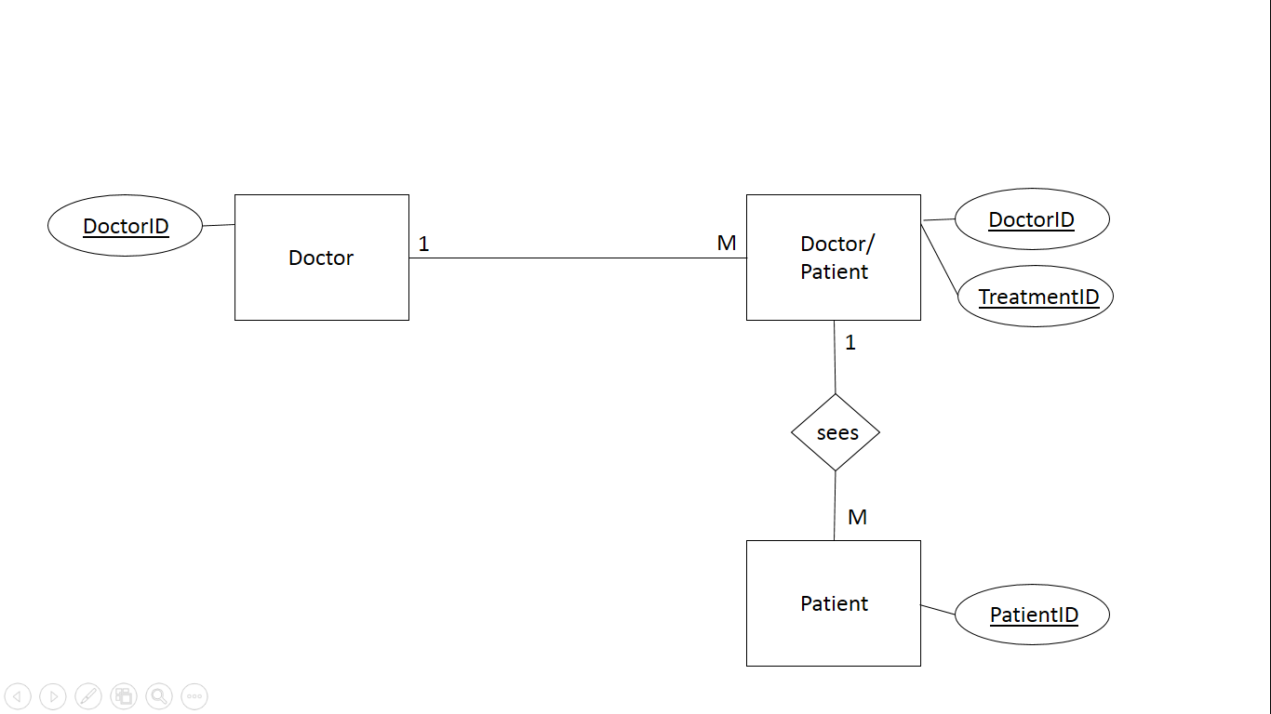

Identify two errors in the ERD.

1

2

**Question 6 (3 marks)**

Describe the purpose of the following database terms.

Primary Key

Cardinality

Entity

**Question 7 (3 marks)**

The specifications of the laptop below are noted on the right side.

|  |  |
| --- | --- |
|  | * HP ZBook 15 G3 4G/LTE Business Mobile Workstation * Notebook 15.6” 1080p Full HD i7-6700HQ 32GB DDR4 RAM 512GB SSD Quadro M2000M 4GB Graphics Win7Pro * 64bit (Win10Pro Lic) 3yr Onsite * Dimensions: 42cm x 30cm x 12cm * Weight: 3.0kg   <https://www.kogan.com/au/buy/hp-zbook-15-g3-4glte-business-mobile-workstat-hp/> |

Using the above information identify the storage capacity for the following:

Hard drive

Graphics card

RAM

**Question 8 (4 marks)**

Using your knowledge of computer systems, identify one item for each of the following categories.

|  |  |
| --- | --- |
| Input |  |
| Processing |  |
| Output |  |
| Storage |  |

**Question 9 (2 marks)**

JBC Inc. have recently employed a systems manager. She notices that the company has no standard operating environment (SOE) and instead has a multitude of devices.

Outline **two** advantages that an SOE can bring to an organisation.

1.

2.

**Question 10 (3 marks)**

Describe how the data, address and control bus work together to process data.

**Question 11 (4 marks)**

Describe the activities that occur during the fetch execute cycle.

**Question 12 (4 marks)**

Preventative maintenance is a process that should be undertaken regularly. Complete the table below and outline an activity that should be completed for each of the time periods. An example has been shown.

|  |  |
| --- | --- |
| Time Period | Activity |
| Example - Daily | Scan for viruses |
| Daily |  |
| Weekly |  |
| Monthly |  |
| Quarterly |  |

**Question 13 (4 marks)**

Each of the following terms belong to the hierarchical structure of data.

Identify the alternative name for each of these.

character

record

table

field

**Question 14 (3 marks)**

Susan has just joined Fortune Group and has been asked to sign an ICT Code of Conduct.

a). Describe what is the purpose of a ICT Code of Conduct. (1 mark).

b). Identify **two** clauses that an ICT Code of Conduct is likely to contain. (2 marks).

**Question 15 (6 marks)**

The following table has a combination of spreadsheet term and definitions. Complete the blanks in the table by either identifying the correct term or giving a definition.

|  |  |
| --- | --- |
| Term | Definition |
|  | Uses predefined formulas such as sum |
| formula |  |
|  | A specific location in a spreadsheet |
| label |  |
|  | A grid of columns and rows |
| vlookup |  |

**Question 16 (6 marks)**

1. Describe the purpose of encryption. (1 mark)

1. Describe how biometrics work in protecting data and provide an example. (2 marks)

1. Describe **three** characteristics of a strong password. (3 marks)

**Question 17 (4 marks)**

The following is a spreadsheet identifying the number of enrolments in a college.

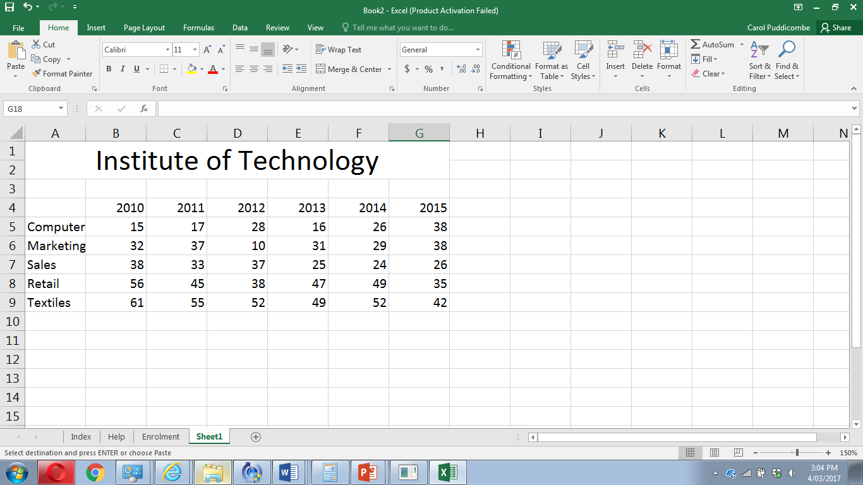

A chart is required to support the data in a report. Choose one chart below and outline your reasons why you believe it should be included in the report.

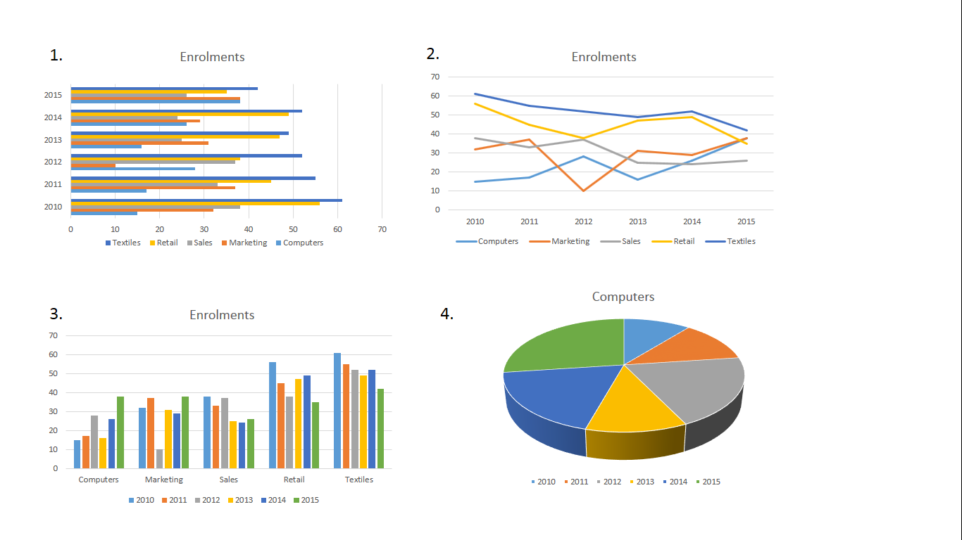

Choice

**Question 18 (3 marks)**

Describe the following database terms:

Relation

Atomicity

Record

**Question 19 (3 marks)**

Describe how cache works.

**Question 20 (3 marks)**

Use the following Context Diagram to answer the questions.

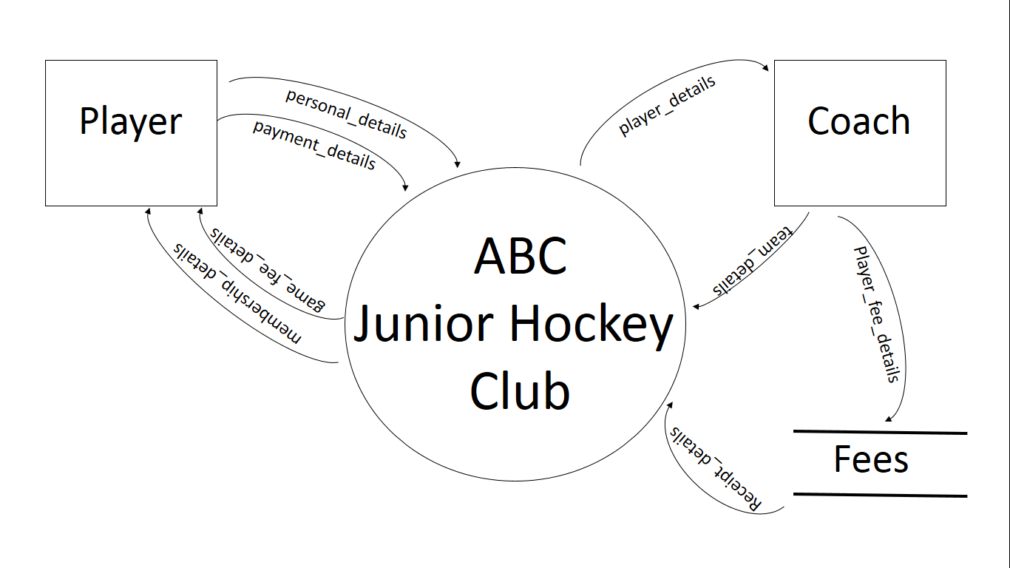

1. What is the primary purpose of the large central circle? (1 mark)

1. Identify an error in the diagram. (1 mark)

1. What is the purpose of the squares in this diagram? (1 mark)

**End of Section One**

**Section Two: Extended answer 60% (72 Marks)**

This section contains **four (4)** questions. You must answer **all** questions. Write your answers in the spaces provided.

Spare pages are included at the end of this booklet. They can be used for planning your responses and/or as additional space if required to continue an answer.

* + Planning: If you use the spare pages for planning, indicate this clearly at the top of the page.
  + Continuing an answer: If you need to use the space to continue an answer, indicate in the original answer space where the answer is continued, i.e. give the page number. Fill in the number of the question(s) that you are continuing to answer at the top of the page.

Suggested working time: 85 minutes.

**Question 21 (22 marks)**

Starshine Insurance Ltd. are an insurance company that deals with car insurance. They are looking to expand into other areas of insurance including house, travel and pet. They have 30 employees based in a building in Perth, Western Australia. Currently, their system uses old technology and is very paper intensive. They have hired a systems analyst to review their current system for inefficiencies and to recommend changes going forward.

1. The analyst has decided to use the Systems Development Life Cycle (SDLC).

Outline **two** reasons why the analyst has decided on this methodology instead of creating a prototype of a new system. (2 marks)

1. Describe **two** activities that the analyst will need to do in the Analysis stage. (2 marks)

1. Describe a tool that could be used in budgeting the project. (1 mark)

Using the following information answer question 21 d and e.

The analyst has uncovered the current quoting and purchase system.

A customer calls to request a car insurance quote. They give their personal details to the call centre person. The call centre person checks the type of car, age, mileage and location in the car spreadsheet and retrieves the price of the insurance. A quote is created and the quote details are given to the customer and filed in the quote spreadsheet. The customer has 30 days to respond to the quote. If the customer decides to purchase the insurance, they call and give the quote details. The call centre retrieves the quote from quote spreadsheet and confirms the details of both the car and personal details of the customer. A purchase order is then created and emailed to the customer. The customer has 30 days to pay for the insurance. Once paid, the customer receives the insurance policy and a receipt and the policy is saved in the policy spreadsheet.

1. Draw the Context diagram for the quoting and purchasing system below. (5 marks)
2. Create the Level 0 Data Flow Diagram (DFD) for the system below. (12 marks)

**Question 22 (14 marks)**

Refer to the image below and answer the following questions.

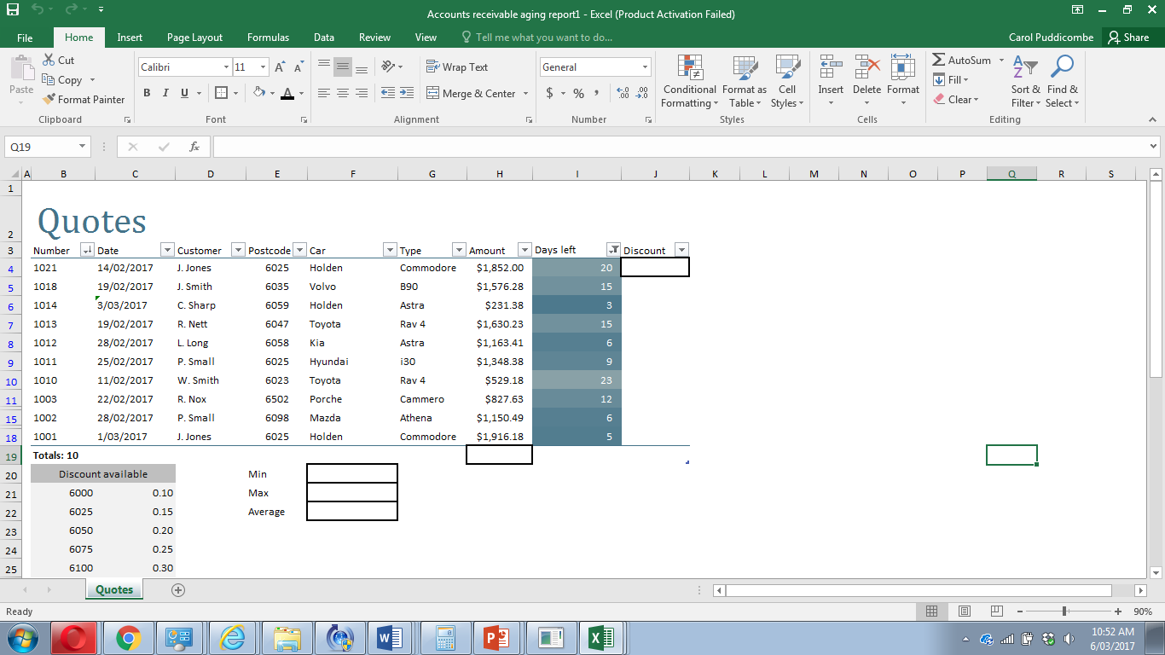

1. What formula would be used in the Min cell F20 to find the minimum quote amount?

(2 marks)

1. What formula would be used in the Max cell F21 to find the maximum quote amount?

(2 marks)

1. What formula would be used in the Average cell F22 to find the average of all quotes?

(2 marks)

1. What formula would be used in cell H19 to add all the amounts? (2 marks)

1. A lookup formula is needed in J4 to find the discount based on the postcode. Write the formula that would be required. (5 marks)

1. What is required in the lookup formula to enable it to be copied down? (1 mark)

**Question 23 (26 marks)**

The analyst has looked at the number of spreadsheets used and has suggested the company use a relational database. The claims spreadsheet is shown below. Use this to answer the following questions.

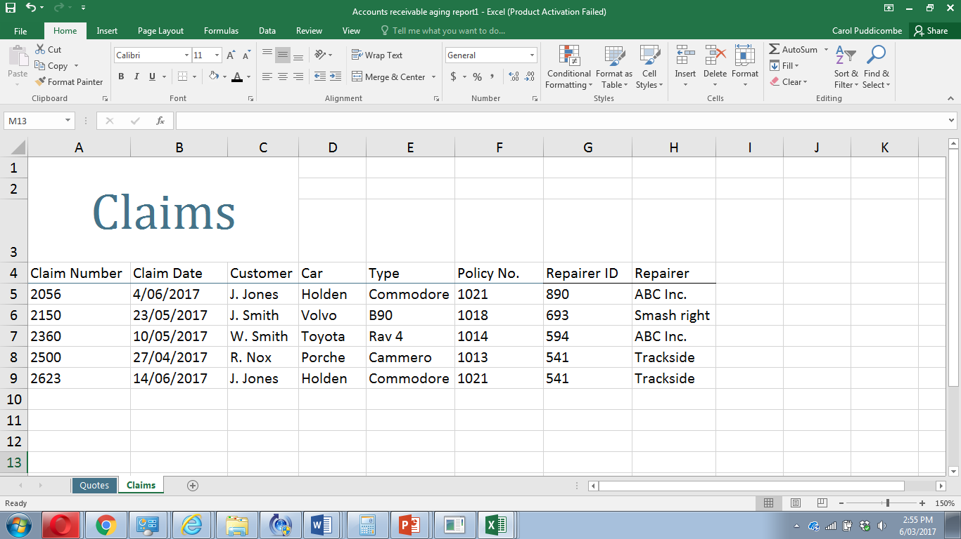

1. Describe **two** issues using data from the spreadsheet that need to be sorted before moving to a database. (4 marks)

1. Describe the following terms using data from the spreadsheet. (4 marks)

Data integrity

Data redundancy

1. Identify the ideal data types for the following from the spreadsheet. (3 marks)

Policy Number

Claim Date

Car

1. The analyst has decided to change the spreadsheet into a database. Using your understanding of databases create an Entity Relationship Diagram (ERD) that would ensure high data integrity and low data redundancy. Ensure you use Chen’s notation. (13 marks)
2. Describe **two** legal requirements of keeping customers personal information that organisations need to comply with. (2 marks)

**Question 24 (10 marks)**

The analyst has recommended that Starshine Insurance Inc. standardise their hardware for their assessors so that it would be easier to maintain. Currently, the assessors write down everything in a pad, return to the office and enter the details. It would be much easier for them to have a device of some sort that they could carry with them.

The analyst has given them two choices outlined below.

|  |  |
| --- | --- |
| Choice 1 | Choice 2 |
| Lenovo Miix 510-9Y 12” 2-in-1 Laptop  $998.00 | Microsoft Surface 3 LTE - 128GB $1069.00 |
| Intel Core i3, 2.3 GHz, 3MB Cache, RAM DDR4 8GB, SSD 128GB, 12 inch screen, multi-touch, HD Graphics inbuilt, wireless, Bluetooth, Windows 10, 12 month warranty Keyboard and removable display | Quad-core intel i7, 2.4 GHz, 2MB Cache, RAM 4GB, SSD 64GB, 10.8” screen, multi-touch, inbuilt graphics, wireless, Bluetooth, Windows 10 Pro, 2 year warranty  Keyboard and removable display |

Decide which one the organisation should choose for this specific purpose. Justify your decision, using your knowledge of primary and secondary storage and key hardware and software components required for a computer system for Starshine.

Choice

Additional working space

Question Number:___________

Additional working space

Question Number:___________

Additional working space

Question Number:___________